MIDTERM EXAMINATION
TIME ALLOWED: 90’
Subject: Linear Algebra.
No Book and Laptop allowed

- Find all complex number(s) such that
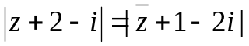 and 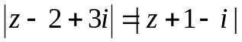

- Let 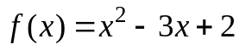 and 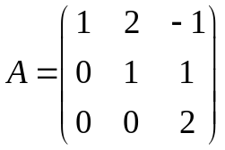. Compute 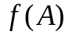.
- Find the matrix X such that 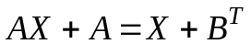, where 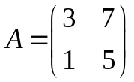, 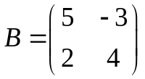.
- Determine all real value(s) m, such that the matrix

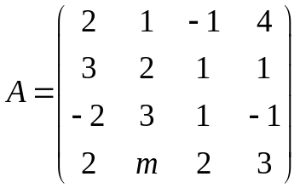 is invertible.

- Solve the following system of linear equations
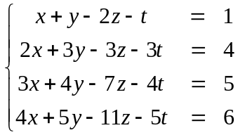

- Determine all value(s) m such that the set

is the spanning set for 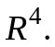

- Let 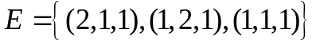 be the basis for 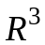.
Find the coordinates of the vector 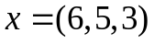 with respect to 
  

